Initial Access Request

1. Open Software Centre to download Putty (x64) ,Proxifier and Notepad ++.
2. Raise an IRIS request to get jumphost access.

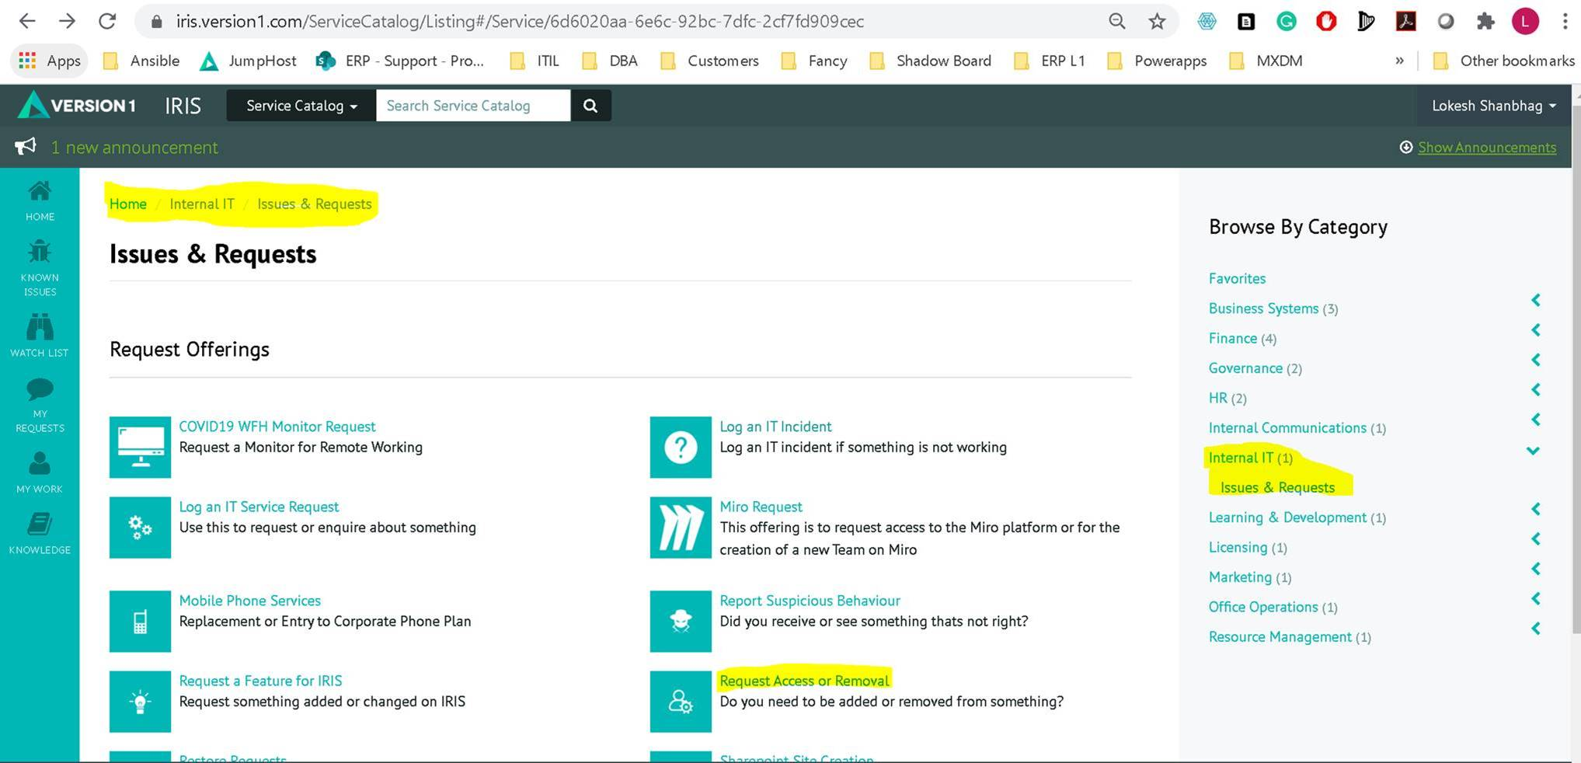

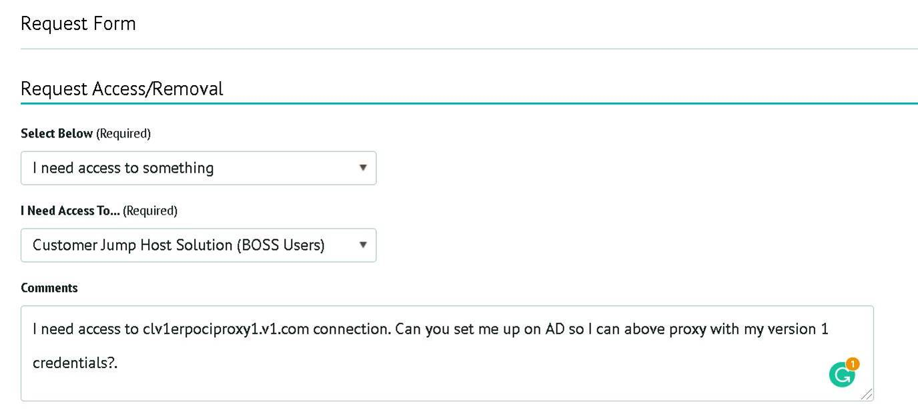

1. Import below Putty Sessions by double clicking on it.



1. Import below Proxifier configurations.



1. Email [servicedesk@version1.com](mailto:servicedesk@version1.com) and ask for PMP access to **V1 – Innovation – Maximise** Resource.

Once you get access to PMP, you can access it by navigating <https://pmp.v1.com/> > Resources > Version 1 > V1 - Innovation – Maximise.

Note:

1. Before accessing any DB, please make sure your proxifier is enabled and you are logged in to cwv1erpociproxy1.v1.com.
2. Just open proxifier to enable it.
3. Open Putty > Load V1 ERP OCI JUMP session > Login with your Version 1 credentials.

Access MXDM and Vision (EBS) database:

**SQL Developer Connection Setting for MXDM:**

1. Username – XXMX_CORE , XXMX_STG, XXMX_XFM (All 3 user has same password)
2. Password – Password stored in PMP
3. Hostname – 10.0.1.192
4. Port - 1521
5. Service Name - MXDM_PDB1.apexfra1red.apexvcn.oraclevcn.com

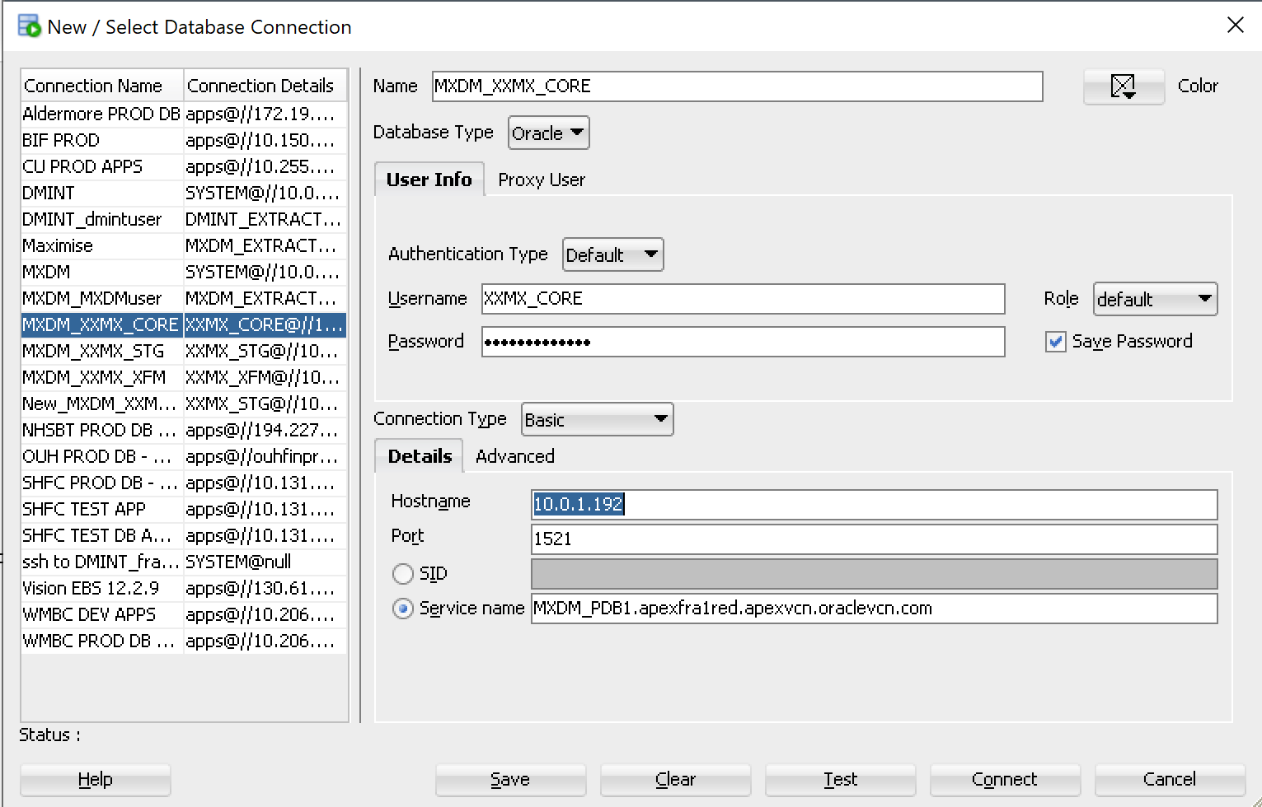

**SQL Developer Connection Setting for Vision (EBS DB):**

1. Username – apps
2. Password – Password stored in PMP
3. Hostname – 130.61.31.168
4. Port - 1521
5. Service Name - ebs_mxebsdb

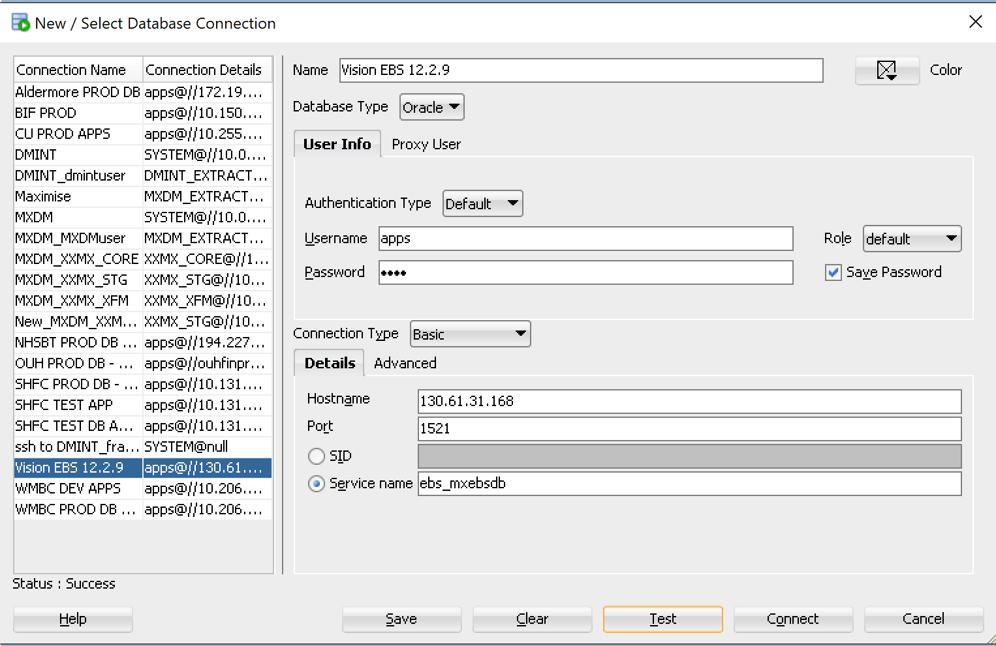

OCI Access:

Lokesh will create user account on OIC instance with all required grants. Once user ID is created, you can login to below link:

<https://oic-mxdm-lr1s8jcgtkv4-ld.integration.ocp.oraclecloud.com/ic/home/> to access OIC.

Vision Front-End Access:

Lokesh will create user account on vision instance with all required roles and permissions. Once user ID is created, you need to add entry to **C:\Windows\System32\drivers\etc\host** file (Edit with Notepad++) to get Vision (EBS) front end access.

(Make sure entry is added to it by saving the file and opening it again)

**# MXDM Vision 12.2.9  
130.61.31.168 vision1228mxdm.example.com vision1228mxdm**

Once host entry is added, login to - <http://vision1228mxdm.example.com:8000/>

Fusion Access:

Lokesh will create Fusion account with required roles and grants. Once user account is created, login to below link:

<https://eccq-test.login.us2.oraclecloud.com/>